Using Microscopes
- Label the parts of the microscope below. All the parts are listed on the right.
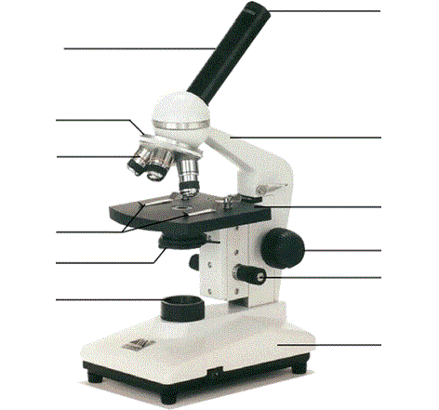
Arm
Base
Revolving Nosepiece
Light Source
Stage
Barrel
Objective Lens
Coarse Focus Knob
Clips
Diaphragm
Fine Focus Knob
Eyepiece Lens

- List three rules for using a microscope.
  - ____________________________________________________________
  - ____________________________________________________________
  - ____________________________________________________________

- Complete the sentences below:
  - When first examining a slide use the ______ power lens.
  - When focussing, only move the stage _______________.
  - When changing to high power, always look from the _______ to make sure the ______________ _______ doesn’t touch the slide.
  - When on high power, only use the ________ focus knob.

- Number the following in the correct order.
______ Place the slide on the stage.
______ Raise the stage to its highest point.
______ Make sure the lowest power objective lens is in place.
______ Lower the stage slowly while looking through the eyepiece.
______ Lower the stage to its lowest point.

Eyepiece Magnification X Objective Magnification = Total Magnification

- The table below indicates the possible combinations of eyepiece and objective lenses.
 |  | Objective Lens
 |  | X10 | X 40 | X 100
Eyepiece Lens | X 5 | X50
Eyepiece Lens | X 10

- Complete the table by working out the total magnification for each combination of lenses. The first one has been completed for you.

- From your table above, what is the lowest possible total magnification?

- What is the highest possible magnification?

- Explain the difference between high power and low power. ___________________ __________________________________________________________________ __________________________________________________________________

- The field of view is the area seen under the microscope. Does low power or high power have the larger field of view? ________________

- You often have to draw what you have seen down a microscope. What rules should you follow when drawing your diagrams?

  - _____________________________________________________________
  - _____________________________________________________________
  - _____________________________________________________________

- Set up your microscope and place the prepared slide of the letter ‘e’ on the stage so that it is the right way up when you look at it. Look at the letter ‘e’ on low power.

- Write the letter ‘e’ as it is normally seen: _________
Now draw the letter ‘e’ as seen down the microscope: _________
What has the microscope done to the orientation letter? __________________ ________________________________________________________________

- Whilst looking down the microscope, carefully and slowly move the slide in the following directions and comment on the way the image in the microscope moves:
    - Towards you __________________________
    - Away from you __________________________
    - To your left __________________________

- Using an arrow, predict the way the image would move if you moved the slide in the direction indicated:

- ii. iii.

- Mini-grid slides can be used to find out the width of your field of view. Knowing how wide the field of view is allows you to estimate the size of the object you are looking at. Each square on the mini-grid is 1mm wide.

One square on the mini-grid slide has even smaller squares inside it. Each one of the smaller squares is 0.1mm wide.

  - Look at the mini-grid slide under low power. How many squares fit across your field of view?

  - What is the diameter (in mm) of your field of view?

  - Change your objective to X40. How many squares fit across the field of view now?

  - What is the diameter (in mm) of the field of view now?

  - Look at you letter ‘e’ slide again under low power. Estimate the size of the letter.

- Look at the prepared slide of pollen grains under low power. Draw what you see in the space below. Remember to write the magnification next to your sketch. (Hint: use magnification table in part 5)

Magnification = __________

- Whilst looking from the side, change the objective lens to the X40 lens. Draw what you see and write the magnification below.

Magnification = __________

Use the field of view measurement from part 10 to estimate the size of the largest blue pollen grain in the centre.

Size of pollen grain is ______________

- What differences can you see between the pollen grains at low power and the pollen grains at a higher power?

